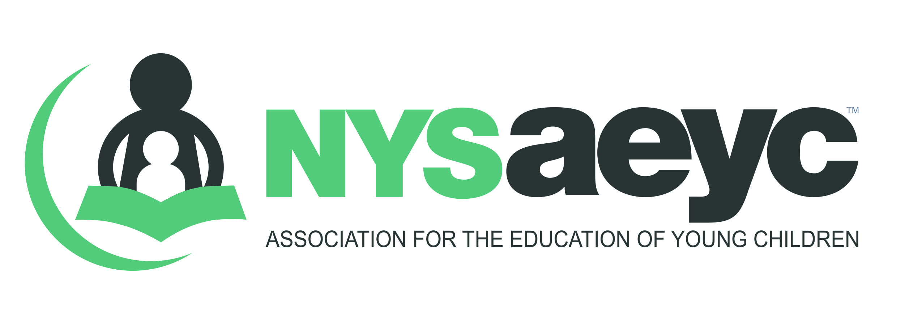
Training and Technical Assistance Professional Credential
Content Specialist
Reference/Verification of Professional Experience in the Content Area

To the reference writer:
You have been asked to serve as a reference for a candidate applying for the New York State Early Learning Trainer Credential as a Content Specialist Trainer. Your reference will be used as a part of the verification process to determine whether the applicant meets the eligibility requirements for the Content Specialist Trainer. The reference you provide will only be used for this purpose; neither the New York State Association for the Education of Young Children (NYSAEYC) or NYC Early Childhood Professional Development Institute (PDI) will forward the reference to universities or to prospective employers.

You have two options for submitting your reference:
1) Print the form, handwrite your responses, and mail the completed form directly to NYSAEYC.
2) Type your reference in a Word document or the body of an email. Be sure to include all of the information requested in this reference form in the content of your response. Then, email your reference to NYSAEYC.

Name of applicant: _________________________________________________ Date: ____________________________

Name of reference writer: ____________________________________________________________________________

Address of reference writer: ___________________________________________________________________________

Phone number of reference writer: _____________________________________________________________________

Email address of reference writer: ______________________________________________________________________

Number of years you have known the applicant in one or both of the following capacities:
Adult Educator/Trainer ____________________________

Professional Work ____________________________ Type of Professional Work ________________________________
Please provide a brief narrative of the applicant based on your experience with him/her. Please describe to the best of your knowledge the following:
- The applicant’s professional experience working in the content area.
and/or
- The applicant’s training experience.
- The quality of the applicants work.
- If the applicant was employed by you or your organization would they be eligible for rehire.
TRAINING REFERENCE ONLY
Using a scale of 1-5 (1=poor 2= Average 3=Good 4= Very Good 5= Excellent) please rate the applicant’s ability in the following areas:

Developing meaningful current curriculum _____ Meeting learning objectives _____

Using of a variety in instructional methods _____ Creating a supportive and flexible environment _____

Actively engaging participants _____ Connecting theory to practice _____

You may:
1) Print this form, type or write your response, narrative can be on your letterhead and mail it in a sealed envelope to:
New York State Training and Technical Assistance Professional Credential Program
NYS Association for the Education of Young Children (NYSAEYC)
230 Washington Avenue Extension
Albany, NY 12203
OR
2) Email your response to credentials@nysaeyc.org. The subject of your email should read: Content Specialist Reference.

